Optical Fiber Attenuation
Student Edition
Name: | Subject(s)/Course(s): Algebra |  | Date:
Synopsis and Narrative:
The school wants to install a 50 meter plastic fiber optic cable for their datacom needs that will connect two sections of the school together. The students are given the task to determine if this is possible given that there is a large power loss over distance in plastic fiber. If running 50 meters of plastic fiber without significant signal losses is possible, at what wavelength should the transmission be sent?
Challenging Question or Problem:
Can LEDs between 470nm and 667.5nm be used to transmit datacom information over 50 meters of plastic fiber optic cable? Which color LED would be best to use and why? What is the maximum distance that datacom information can be transmitted on a plastic fiber based on color?
Phenomenon and Manufacturing Application:
Engineering and manufacturing of fiber optic cable depending on the use. The purchase and installation of fiber optic cable types depending on use.
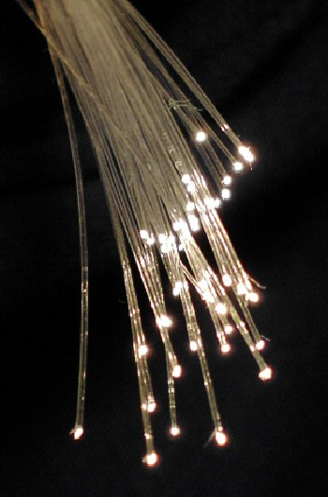  Examples (in action):  Fiber optic transmission of phone and data used in the telecom industry. Fiber optics used in the lighting industry to transmit light without heat.  A Bundle of Optical Fibers  https://en.wikipedia.org/wiki/Optical_fiber#/media/File:Fibreoptic.jpg |  |  |  | Vocabulary:  Fiber Optic  Wavelength  Power  Intensity  Rayleigh Scattering  Absorption  Bending  Decibel  Light Emitting Diode
State and National Standards & 21st Century Skills:
AI-A.CED.1 - Create equations and inequalities in one variable to represent a real-world context.
AI-A.CED.2 - Create equations and linear inequalities in two variables to represent a real-world context.
Practices MP.2 - Students are reasoning abstractly when they create abstract algebraic models of problems
Practices MP.8 - An effective way to help students develop the skill of describing general relationships is to work through several specific examples and then express what they are doing with algebraic symbolism

AI-S.ID.5 - Summarize categorical data for two categories in two-way frequency tables. Interpret relative frequencies in the context of the data (including joint, marginal, and conditional relative frequencies). Recognize possible associations and trends in the data.
AI-S.ID.6 - Represent bivariate data on a scatter plot, and describe how the variables’ values are related.
AI-S.ID.6a - Fit a function to real-world data; use functions fitted to data to solve problems in the context of data.
AI-S.ID.7 - Interpret the slope (rate of change) and the intercept (constant term) of a linear model in the context of the data.
AI-S.ID.8 - Calculate (using technology) and interpret the correlation coefficient of a linear fit.
AI-S.ID.9 - Distinguish between correlation and causation.
AI-F.LE.5 - Interpret the parameters in a linear or exponential function in terms of a context.

Materials and Equipment:
1 Breadboard
1 Red, yellow, green, and blue LED
1 Battery box with batteries
10 Alligator leads
1 0.5m fiber optic cable
1 10m fiber optic cable
1 20m fiber optic cable
1 30m fiber optic cable
1 photometer
Safety:
If the leads from the battery box get connected together (shorted) while the battery box switch is in the on position, the batteries and wire will heat up and could cause burns.
Learning Targets:
- Students will create a plot and fit a function to the data in order to answer the question.
- Students will recognize associations and trends in the plotted data, interpreting the slopes of the line.
- Students will describe how the variables of frequency and distance are related.
- Students will use the equation for each trendline to predict the attenuation loss at 50 meters and the maximum distance of fiber optic that can be run.

Introduction/Warmup:
Read “fiber optics” and answer the text dependent question found below.

Fiber Optics
Fiber optics is a technology that uses glass or plastic fiber to transmit light. The light can be used to transmit data or other forms of information at the speed of light. Fiber optics work using the propagation of light through an optical core that is highly transparent surrounded by cladding that is another type of glass, plastic, or material. This phenomenon is based on the principle of total internal reflection, where the light is reflected off the inside surface as it propagates along the fiber (see diagram below).
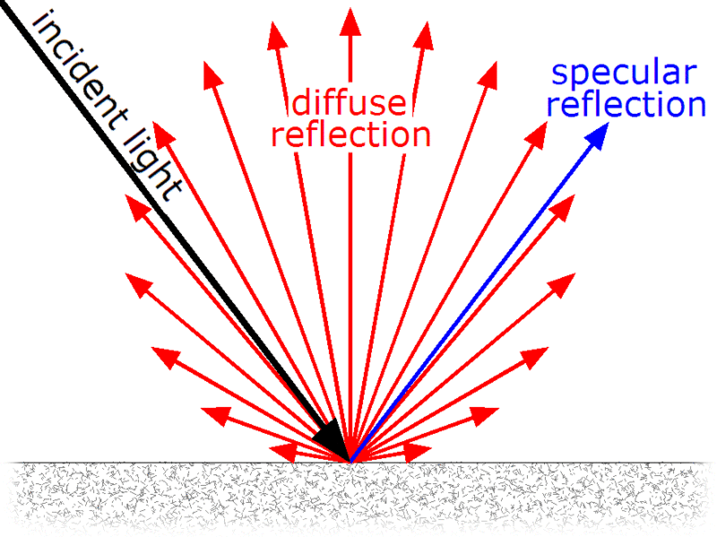
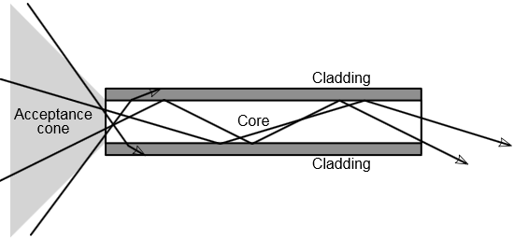
By GianniG46 - Own work, CC BY-SA 3.0, https://commons.wikimedia.org/w/index.php?curid=11902338

As light propagates through the fiber it loses intensity. In science, intensity means the amount of energy in a certain area. Intensity loss in fiber optics means that the luminosity (how bright the light is) of light decreases in the fiber optic as it moves along. The loss of light intensity in the fiber is primarily due to the scattering of light when diffuse reflection occurs on a rough or irregular surface of the fiber at the molecular level. Light that is diffusely reflected gets absorbed by the cladding of the fiber optic. Only light that is specularly reflected continues to propagate along the fiber.

The amount of light that gets scattered depends on the wavelength of light used. This is known as Rayleigh scattering, where shorter (blue) wavelengths are scattered more strongly than longer (red) wavelengths. This is also the reason behind why the sky is blue. One of the main challenges that industry has when making fiber optic cable is reducing diffuse reflection while maximizing specular reflection.

Fiber optics have many advantages over traditional electrical forms of transmission.
- Fiber optics have much greater bandwidth, meaning that they can carry more information at once and at a faster rate.
- Glass fiber optic cables have the ability to transmit data over very long distances. Glass cables have very low attenuation and high signal quality. It is not unusual for fiber optic transmission lines to span more than 100 km (~62 miles) at a time. Traditional metal cables are only capable of going a couple of kilometers (~1 mile) before requiring a boost in signal strength.
- Fiber optic cables are much thinner and lighter than traditional metal cables.
- Fiber optic cables are not conductive to electricity. This means that they are not susceptible to radio or other forms of electromagnetic interference.
- Fiber optic cables are more secure as it is impossible to remotely detect the signal being transmitted within the cable without directly accessing the cable. Accessing the fiber requires intervention that is easily detectable by the users on either end of the cable. Traditional metal cables can be compromised without ever touching the actual cable.
Limitations of fiber optic cables
- New infrastructure costs. Installing fiber optic networks is a large expenditure for service providers such as Time Warner cable. Old infrastructures such as DSL and cable are still servicing customers.
- Maintenance and equipment costs. Test equipment for fiber optics is more expensive then the equipment required for copper based cables. IT departments would have to “retool” all of their equipment if they switch over.
- Susceptible to physical damage. Fiber optic cables tend to be more fragile than copper based cables. There’s a greater risk for the cable to be damaged or cut during the installation process or during construction activities. When fiber optic cables are chosen as the main medium for data transmission to large groups of people, it is necessary to have a backup.
Uses of Fiber Optic Cables
Fiber optic cables find many uses in a wide variety of industries and applications.
Some uses of fiber optic cables by Timbercon, Inc., include:
- Medical
  - Used as light guides, imaging tools, and as lasers for surgeries
- Defense/Government
  - Used as hydrophones for seismic and SONAR uses, as wiring in aircraft, submarines, and other vehicles, and also for field networking
- Data Storage
  - Used for data transmission
- Telecommunications
  - Fiber is laid and used for transmitting and receiving purposes
- Networking
  - Used to connect users and servers in a variety of network settings and help increase the speed and accuracy of data transmission
- Industrial/Commercial
  - Used for imaging in hard to reach areas, as wiring where EMI is an issue, as sensory devices to make temperature, pressure, and other measurements, and as wiring in automobiles and in industrial settings
- Broadcast/CATV
  - Broadcast/cable companies are using fiber optic cables for wiring CATV, HDTV, internet, video on-demand, and other applications
- Lighting
  - Fiber optic cables are used for lighting, imaging, and as sensors to measure and monitor a vast array of variables. Fiber optic lighting is becoming very common in the automotive industry due to their ability to conserve space.

Text Dependent Question:
New York State would like to update the data communications infrastructure across the state in hopes of attracting more businesses. Compose a conclusion or claim that states why or why not the infrastructure upgrades should be completed with fiber optics. Use evidence found in the article with an explanation to make your claim.
____________________________________________________________________________________________________________________________________________________________________________________
____________________________________________________________________________________________________________________________________________________________________________________
____________________________________________________________________________________________________________________________________________________________________________________
____________________________________________________________________________________________________________________________________________________________________________________
____________________________________________________________________________________________________________________________________________________________________________________
____________________________________________________________________________________________________________________________________________________________________________________
____________________________________________________________________________________________________________________________________________________________________________________
____________________________________________________________________________________________________________________________________________________________________________________
____________________________________________________________________________________________________________________________________________________________________________________
____________________________________________________________________________________________________________________________________________________________________________________
____________________________________________________________________________________________________________________________________________________________________________________
____________________________________________________________________________________________________________________________________________________________________________________
____________________________________________________________________________________________________________________________________________________________________________________
____________________________________________________________________________________________________________________________________________________________________________________
____________________________________________________________________________________________________________________________________________________________________________________
____________________________________________________________________________________________________________________________________________________________________________________

Collecting The Data: Measuring the attenuation of a fiber optic cable.

- Connect the battery box to the breadboard by attaching the red lead to the red positive terminal strip on the breadboard and the black lead to the negative blue terminal strip on the breadboard. Turn the battery box on (see diagram below)

- Wire one blue 5mm LED in parallel on the same terminal strip of the breadboard according to the schematic. The positive side of the LED is the longer lead. The negative side of the LED is the shorter lead. The LED’s should light up with their respective color (see diagram below).

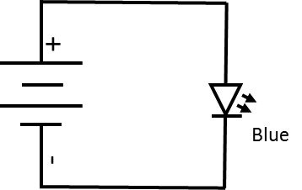

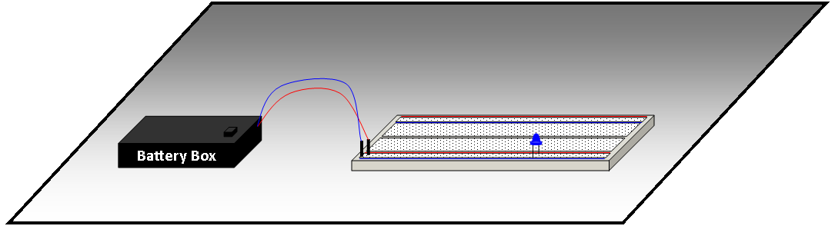

- Using the 0.5m fiber optic cable, attach the end that has the washer to the photometer detector assembly. This is done by inserting the fiber optic coupler into the photometer detector until the washer is flush to the surface (see diagram below).

- Insert the other side of the fiber optic coupler onto the blue LED on the breadboard. The coupler should simply snap over the LED (see diagram below).

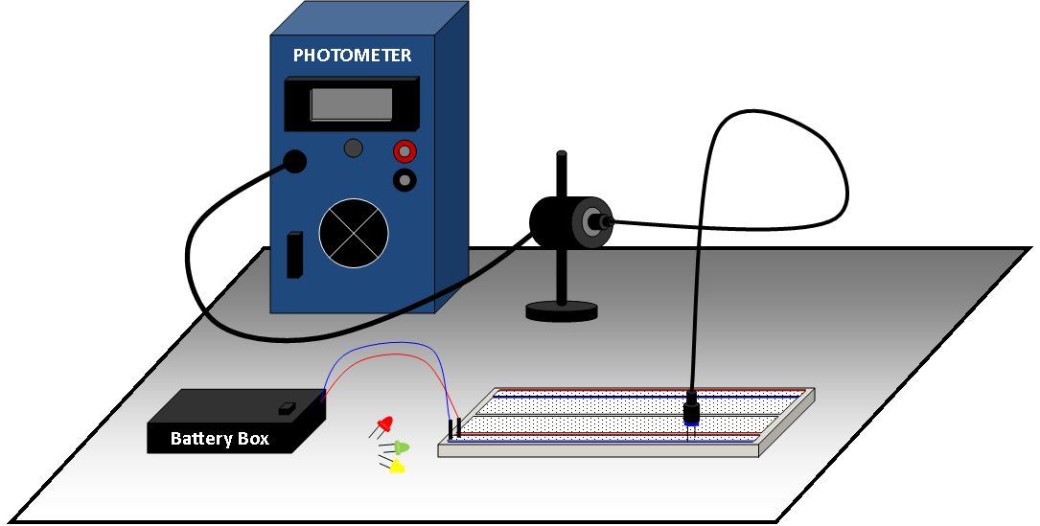

- Set the photometer selector switch to the 200μW range. Press and hold the on/off switch until the reading on the photometer stabilizes, or after 15 seconds, then record the reading on the photometer in the table below.

 |  | Light Power (μW)
Color | Wavelength (nm) | 0.5m | 10m | 20m | 30m
Blue | 668
Green | 575
Yellow | 525
Red | 470

When removing connections from the couplers, never pull of the fiber optic cable. Always have a firm grip on the coupler and LED itself.

- Remove the blue LED from the breadboard and the coupler. Insert a green LED into the coupler and then plug the LED into the breadboard. You should see the green LED light up.

- Repeat step 5.

Remember; never pull of the fiber optic cable. Always have a firm grip on the coupler and LED itself.

- Remove the green LED from the breadboard and the coupler. Insert a yellow LED into the coupler and then plug the LED into the breadboard. You should see the yellow LED light up.

- Change the photometer selector switch to the 20μW range. Press and hold the on/off switch until the reading on the photometer stabilizes, or after 15 seconds, then record the reading on the photometer in the table below.

- Repeat steps eight and nine for the Red LED.

- Replace the 0.5 m fiber optic with the 10 m fiber optic and repeat steps 2 through 9.

Be careful when removing the photometer detector. Make sure you have a firm grip on the coupler and the photometer detector, never pull on the fiber optic itself.

- Replace the fiber optic cable with the 20 m and finally the 30 m cable after repeating steps 2 through 9.

 |  | Light Power (μW)
Color | Wavelength (nm) | 0.5m | 10m | 20m | 30m
Blue | 668
Green | 575
Yellow | 525
Red | 470

- Convert the light power from microwatts (μW) to milliwatts (mW). Record your results in the table below?

 |  | Light Power (mW)
Color | Wavelength (nm) | 0.5m | 10m | 20m | 30m
Blue | 668
Green | 575
Yellow | 525
Red | 470

As light propagates through the fiber optic, the light intensity decreases exponentially as a function of distance.

There are several causes of attenuation in an optical fiber: Rayleigh scattering, absorption, and optical fiber bending. Research each of these terms and fill out the vocabulary table below.

 | Definition | What is happening inside of a fiber optic cable? | Picture or Diagram
Rayleigh Scattering | _____________________  _____________________  _____________________  _____________________  _____________________ | _____________________  _____________________  _____________________  _____________________  _____________________
Light Absorption | _____________________  _____________________  _____________________  _____________________  _____________________ | _____________________  _____________________  _____________________  _____________________  _____________________
Optical Fiber Bending | _____________________  _____________________  _____________________  _____________________  _____________________ | _____________________  _____________________  _____________________  _____________________  _____________________

To counter this exponential loss, attenuation is measured in decibels. The decibel (dB) is a logarithmic unit that is used to express the ratio of intensity to a standard reference value.

- What will happen to the exponential function of decreasing power loss when we convert the power to decibels? Explain your reasoning.
______________________________________________________________________________________________________________________________________________________________________________
______________________________________________________________________________________________________________________________________________________________________________
______________________________________________________________________________________________________________________________________________________________________________
______________________________________________________________________________________________________________________________________________________________________________
Decibels need to have a standard reference value. Attenuation loses in industry base that standard reference value on 1 milliwatt, or 1mW. Decibels based on the 1mW standard reference value are often referred to as decibel-milliwatts or dBm. Therefore, a level of 0 dBm is equal to the power of 1 mW.

The unit conversion of power (in milliwatts) to dBm is $dBm=10l{og}_{10}\frac{P(mW)}{1mW}$

- Convert the light power from milliwatts to decibels of light (dBm) in the table below.

 |  | Decibels of Light (dBm)
Color | Wavelength (nm) | 0.5m | 10m | 20m | 30m
Blue | 668
Green | 575
Yellow | 525
Red | 470

- In Excel, create an attenuation graph for decibels (dBm) vs distance of fiber (m).

- Using the graph, create a line of best fit and determine the equation for the line of best fit assuming a linear relationship.

Datacom transmission equipment operates between the 0 and -30dBm power range. Below this range the signal to noise ratio becomes too small to transmit data accurately.

- Determine the maximum usable transmission range for red, yellow, green, and blue LED’s. Show all work below.

Max Distance (m) Red = ______________
Max Distance (m) Yellow = ___________
Max Distance (m) Green = ____________
Max Distance (m) Blue = ______________

- Can the red, yellow, green, or blue LED’s be used to transmit datacom information over 50 meters of plastic fiber optic cable?
Red LEDs: __________________________________________________________________________
Yellow LEDs: _______________________________________________________________________
Green LEDs: ________________________________________________________________________
Blue LEDs: __________________________________________________________________________

- Which color LED would be best to use and why? What is the attenuation at 50 meters for the particular color LED? Show all work below.

______________________________________________________________________________________________________________________________________________________________________________
______________________________________________________________________________________________________________________________________________________________________________
______________________________________________________________________________________________________________________________________________________________________________
______________________________________________________________________________________________________________________________________________________________________________
______________________________________________________________________________________________________________________________________________________________________________
______________________________________________________________________________________________________________________________________________________________________________

